Need a Tredence credentials to login to the outlook,

This will be configured by the IT team,

1. Outlook,
2. FortiGate desktop agent
3. FortiGate token to be installed on mobile.
4. MS Authenticator to be installed on mobile. (this is for Tredence)
5. Request the software thru <https://itservicedesk.tredence.com/MDLIncidentMgmt/IM_MyTickets.aspx?feedback=true>

Below are the

Note: make sure that you connect to FortiGate client vpn if you are WFH (in office this vpn is not required to connect, this is for office vpn network to connect)

Below are the software’s required to install,

Unapproved need to send request to **Suryadipta Chakraborty**

Approved can be sent to the IT team directly.

WSL2 need to send request to

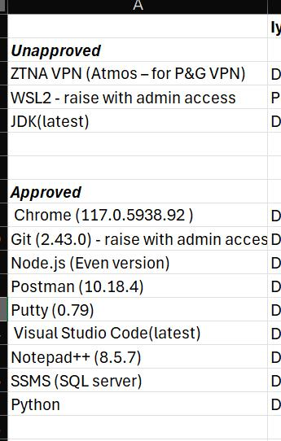

1. Atmos agent to be installed 🡪 this is for P&G client VPN to connect.
2. PGID to be installed on mobile.
3. 1password to be installed on mobile 🡪 this is for P&G client. (2factor authentication)

Once all the above are installed, then send a request to your manager for client setup.

1. P&G account to setup
2. Git hub access to setup with 2-factor authentication.

Post man e-form to be filled by user for P&G

[Postman Access Management - Fulfillment Request - ITSM Service Portal (service-now.com)](https://pgglobalenterprise.service-now.com/itsm?id=sc_cat_item&table=sc_cat_item&sys_id=efb9dd7a97c53150bdc07f171153af16)

Fill the details and click on order button.